**Project title:**FreelanceFinder:Discovering opportunities,

Unclocking Potential

**Team members:** Atkuri Vasundara

Annapareddy Ram Nithin Reddy

Anumukonda Abhinayasri

Anusha Kadaru

**Team id:**LTVIP2025TMID54940

**ABSTRACT :-**

This project outlines **FreelanceFinder**, an innovative web platform designed to seamlessly connect freelancers with clients, addressing the fragmented nature of the current gig economy. The platform aims to empower freelancers by providing a robust space to showcase their skills, find relevant projects, and ensure secure payments, while simultaneously simplifying the hiring process for clients by offering efficient talent discovery, transparent project management, and reliable delivery. Our core objectives include launching an MVP within six months, achieving substantial user acquisition, facilitating a high volume of successful project completions, and maintaining exceptional user satisfaction. Utilizing a modern technology stack and an Agile development approach, FreelanceFinder will initially focus on essential features such as user profiles, project posting, secure communication, and an escrow payment system. By fostering a secure, efficient, and user-friendly ecosystem, FreelanceFinder seeks to unlock the full potential of independent professionals and provide businesses with on-demand access to specialized talent, ultimately contributing to economic growth in the flexible work landscape.

**2. INTRODUCTION:-**

**2.1 Introduction**

**FreelanceFinder** is an innovative web platform seamlessly connecting freelancers with clients to discover opportunities and unlock potential in the gig economy.

**2.2 Existing System**

The current freelance market is fragmented, dominated by generalist platforms with varying quality.

Clients struggle to find specialized talent, while freelancers face intense competition and often lower rates.

These existing systems present significant challenges in reliable vetting, efficient discovery, and secure project management.

**Disadvantages**

High Competition & Rate Depression

Vetting & Quality Inconsistency

Payment & Dispute Challenges

**2.3 Proposed System**

FreelanceFinder offers a streamlined platform to connect skilled freelancers with ideal projects. It features robust vetting, secure escrow payments, and intuitive project management tools for seamless collaboration. Our system will leverage advanced matching algorithms to ensure optimal talent-opportunity alignment. This aims to empower freelancers with fair compensation and consistent work, while providing clients with reliable access to quality expertise.

**Advantages**

Enhanced Talent Discovery & Matching

Improved Quality Assurance & Reliability

Secure & Transparent Financial Transactions

Streamlined Project Management & Communication

**3. System Analysis:-**

**3.1 Study of the system:**

System Analysis thoroughly investigates the current freelance market and user needs.

It identifies critical pain points for both freelancers and clients, like high competition and unreliable talent discovery.

Key activities include detailed functional and non-functional requirements gathering.

This phase defines what the system must do (e.g., profiles, project posting, payments).

It also specifies how well it must perform (e.g., security, scalability, usability).

A crucial feasibility study assesses technical, economic, and operational viability.

Data modeling, using ER diagrams, maps relationships between system entities.

Data flow diagrams illustrate the movement of information within the platform.

User personas and use cases define typical user interactions and their goals.

Ultimately, System Analysis ensures FreelanceFinder is a robust, user-centric solution addressing real-world market gaps.

**3.1.1 Feasibility study:**

A feasibility study for "FreelanceFinder" assesses if the project is viable and achievable.

Technical Feasibility confirms our ability to build the system with existing technologies and expertise.

Economic Feasibility evaluates financial viability, ensuring projected benefits outweigh development costs.

Operational Feasibility determines if the system aligns with user workflows and can be effectively adopted.

Schedule Feasibility confirms the project can be completed within the planned timeline.

This comprehensive analysis identifies potential risks and informs a go/no-go decision for development.

It ensures our significant investment in FreelanceFinder is justified and poised for success.

**3.2Modules**

User Management Module

Project Management Module

Search & Matching Module

**Adimin Module**:

Login

User & Content Management

Financial & Transaction Monitoring

Dispute Resolution & Support

Analytics & Reporting

**User module:**

Registration & Login

Account Settings

Notifications

**Patient Module:**

Patient Demographics

Medical History

Appointments & Scheduling

Vitals & Readings

Diagnosis & Treatment Plans

Medication Management

Lab Results & Imaging

**3.3 Architecture of my project**

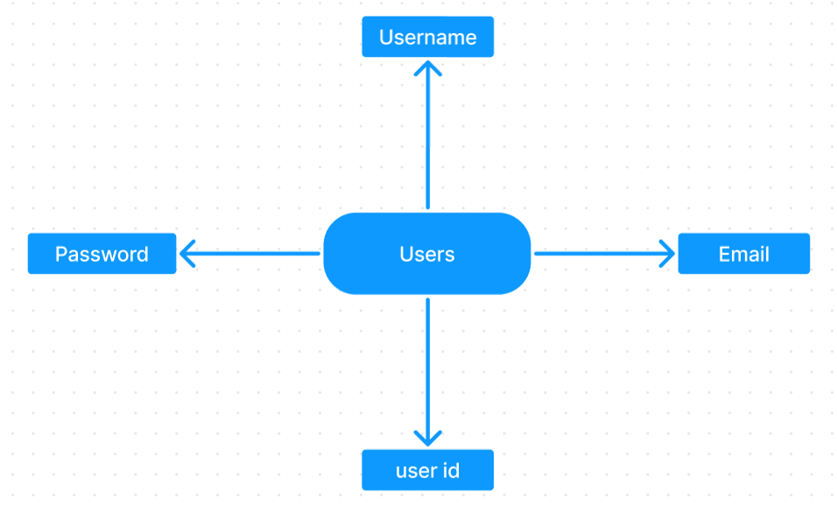

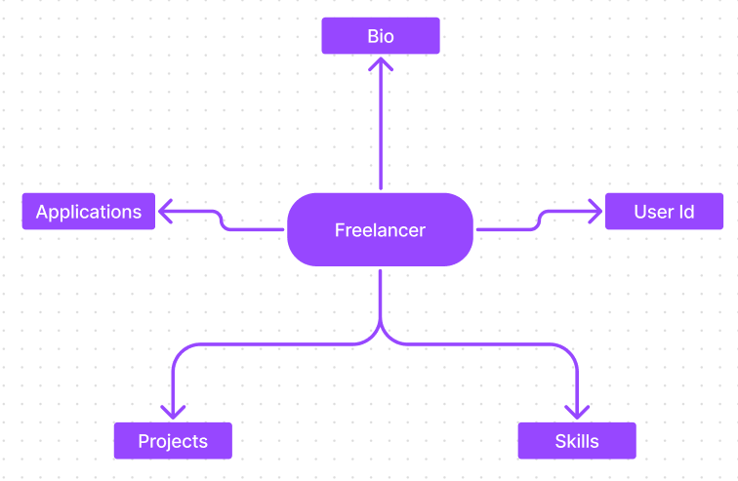

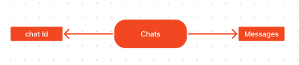

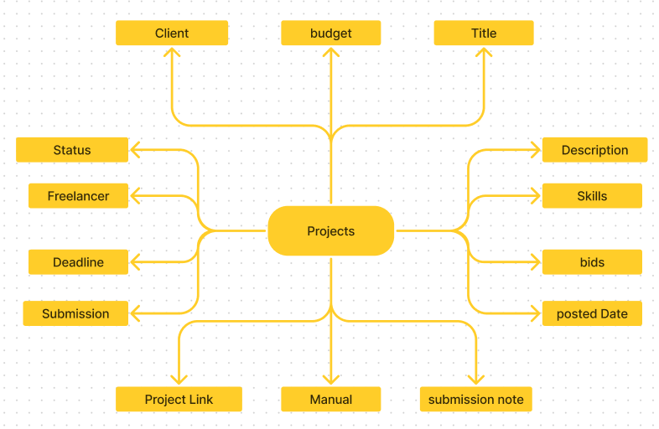

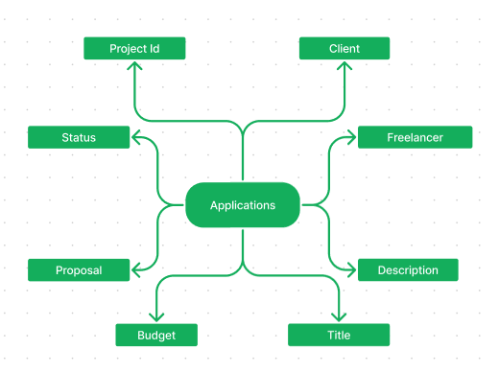

**Implementation code:-**

**1)Client:** const reportWebVitals = onPerfEntry => {

if (onPerfEntry && onPerfEntry instanceof Function) {

import('web-vitals').then(({ getCLS, getFID, getFCP, getLCP, getTTFB }) => {

getCLS(onPerfEntry);

getFID(onPerfEntry);

getFCP(onPerfEntry);

getLCP(onPerfEntry);

getTTFB(onPerfEntry);

});

}

};

export default reportWebVitals;

index: import React from 'react';

import ReactDOM from 'react-dom/client';

import './index.css';

import App from './App';

import reportWebVitals from './reportWebVitals';

import {BrowserRouter} from 'react-router-dom';

import GeneralContextProvider from './context/GeneralContext';

const root = ReactDOM.createRoot(document.getElementById('root'));

root.render(

<React.StrictMode>

<BrowserRouter>

<GeneralContextProvider>

<App />

</GeneralContextProvider>

</BrowserRouter>

</React.StrictMode>

);

// If you want to start measuring performance in your app, pass a function

// to log results (for example: reportWebVitals(console.log))

// or send to an analytics endpoint. Learn more: https://bit.ly/CRA-vitals

reportWebVitals();

**Server:** import mongoose, { Schema, mongo } from "mongoose";

const userSchema = mongoose.Schema({

username: {

type: String,

require: true

},

email: {

type: String,

require: true,

unique: true

},

password: {

type: String,

require: true

},

usertype:{

type: String,

require: true

}

})

const freelancerSchema = mongoose.Schema({

userId: String,

skills: {

type: Array,

default: []

},

description: {

type: String,

default: ""

},

currentProjects: {

type: Array,

default: []

},

completedProjects: {

type: Array,

default: []

},

applications: {

type: Array,

default: []

},

funds: {

type: Number,

default: 0

},

})

const projectSchema = mongoose.Schema({

clientId: String,

clientName: String,

clientEmail: String,

title: String,

description: String,

budget: Number,

skills: Array,

bids: Array,

bidAmounts: Array,

postedDate: String,

status: {

type: String,

default: "Available"

},

freelancerId: String,

freelancerName: String,

deadline: String,

submission: {

type: Boolean,

default: false

},

submissionAccepted: {

type: Boolean,

default: false

},

projectLink: {

type: String,

default: ""

},

manulaLink: {

type: String,

default: ""

},

submissionDescription: {

type: String,

default: ""

},

})

const applicationSchema = mongoose.Schema({

projectId: String,

clientId: String,

clientName: String,

clientEmail: String,

freelancerId: String,

freelancerName: String,

freelancerEmail: String,

freelancerSkills: Array,

title: String,

description: String,

budget: Number,

requiredSkills: Array,

proposal: String,

bidAmount: Number,

estimatedTime: Number,

status: {

type: String,

default: "Pending"

}

})

const chatSchema = mongoose.Schema({

_id: {

type: String,

require: true

},

messages: {

type: Array

}

})

export const User = mongoose.model('users', userSchema);

export const Freelancer = mongoose.model('freelancer', freelancerSchema);

export const Project = mongoose.model('projects', projectSchema);

export const Application = mongoose.model('applications', applicationSchema);

export const Chat = mongoose.model('chats', chatSchema);

**TESTING &SCREENS:-**

TESTING INTRODUCTION

SYSTEM TESTING

System Testing for FreelanceFinder will involve a comprehensive evaluation of the fully integrated software to ensure it functions as a cohesive unit and meets all defined requirements before deployment. This phase is typically a black-box testing approach, focusing on the system's external behavior from a user's perspective.

**TYPES OF TESTS**

1. **Unit Testing:** Tests individual components or units of code in isolation.
2. **Integration Testing:** Verifies interaction and interfaces between combined software modules.
3. **System Testing:** Evaluates the complete, integrated system against all functional and non-functional requirements.
4. **Acceptance Testing (UAT):** Final testing by end-users to confirm the system meets business needs.
5. **Performance Testing:** Assesses system speed, responsiveness, and stability under various loads (e.g., Load, Stress testing).
6. **Security Testing:** Identifies vulnerabilities to protect against unauthorized access and data breaches.
7. **Usability & Compatibility Testing:** Ensures the system is user-friendly and works across different environments (browsers, devices).
8. **Integration testing**

Integration Testing is the phase in software testing that focuses on verifying the interactions and interfaces between different software units or modules that have already been individually unit-tested. It comes after unit testing and typically precedes system testing.

**Purpose:** The main purpose of integration testing is to expose faults in the interaction between integrated units. It aims to ensure that:

* Data is passed correctly between modules.
* Communication protocols between components are working as designed.
* Interfaces connecting different modules or external systems (like APIs, databases) function seamlessly.
* Functionality that spans across multiple modules operates correctly when those modules are combined.

**Key Characteristics:**

* **Focus on Interfaces:** Unlike unit testing which focuses on individual code blocks, integration testing specifically targets the "seams" where modules connect.
* **Incremental Approach (Often):** Instead of putting all modules together at once, they are often integrated in stages, which helps in isolating defects to specific integration points.
* **Earlier Defect Detection:** By identifying integration issues early in the development cycle, it reduces the risk of more severe and costly problems later on in system or acceptance testing.
* **Ensures Compatibility:** Verifies that different components are compatible with each other and can communicate effectively.

**Functional test**

1. **Functional Testing** verifies that each feature of the software works according to specified requirements.
2. It focuses on the "what" the system does, rather than "how" it does it.
3. This includes testing user logins, project posting, search filters, and payment processing.
4. Testers simulate real user scenarios to ensure all functions perform correctly.
5. It's typically a black-box testing approach, without needing internal code knowledge.
6. The goal is to confirm the system meets all business and user expectations.

**System testing**

System testing evaluates the complete, integrated software as a whole.

It verifies that the entire system meets all specified functional and non-functional requirements.

This stage checks end-to-end user workflows, simulating real-world scenarios.

It's crucial for identifying defects arising from module interactions or external integrations.

Key aspects include performance, security, usability, and compatibility checks.

The goal is to ensure overall system stability, reliability, and readiness for deployment.

It provides confidence that the software will perform as expected in its intended environment.

**White Box Testing**

1. **White Box Testing** is a software testing method that examines the internal structure, design, and coding of an application.
2. Also known as Clear Box, Glass Box, or Structural Testing, it requires testers to have full knowledge of the source code.
3. Test cases are designed by inspecting the code's logic, internal paths, and data flow.
4. It's typically performed by developers during Unit and Integration testing phases.
5. Its primary goal is to uncover hidden errors, security vulnerabilities, and inefficient code at a granular level.
6. Techniques like Statement, Branch, and Path Coverage ensure thorough testing of code execution.
7. While complex and time-consuming, it leads to early defect detection and improved code quality.

**Black Box Testing**

1. **Black Box Testing** evaluates software functionality without knowing its internal code structure or design.
2. Testers interact with the application solely through its user interface, providing inputs and observing outputs.
3. It's often called Behavioral or Input/Output-driven testing, focusing on user perspective.
4. Test cases are derived from software requirements, specifications, and user stories.
5. This method primarily verifies what the system *does* rather than *how* it does it.

**Unit Testing**

1. **Unit Testing** is the first level of software testing, focusing on individual components or "units" of code.
2. A "unit" is the smallest testable part of an application, such as a function, method, or class.
3. Developers typically perform these tests during the coding phase using automated test frameworks.
4. The goal is to verify that each unit of code performs its specific function correctly in isolation.
5. It helps in early detection of bugs, making them cheaper and easier to fix.
6. Unit tests ensure that changes or additions to the codebase don't break existing functionalities within a unit.
7. They provide immediate feedback to developers, significantly improving code quality and maintainability.

**Test objectives**

1. To identify and prevent defects, bugs, and errors in the software as early as possible.
2. To verify that all specified functional and non-functional requirements are met.
3. To validate that the software works as expected and satisfies user needs and expectations.
4. To ensure the overall quality, reliability, and performance of the software product.
5. To build confidence in the software's stability and readiness for deployment.
6. To mitigate risks associated with software failures and ensure data security.
7. To provide accurate information on software quality to stakeholders for informed decision-making.

**Features to be tested**

1. **User Authentication:** Testing robust registration, secure login, and password management for both freelancers and clients.
2. **Profile Management:** Verifying comprehensive profile creation, editing, portfolio uploads, and skill declarations for freelancers.
3. **Project Lifecycle:** Ensuring seamless client project posting, freelancer proposal submission, acceptance, and rejection workflows.
4. **Search & Filtering:** Validating accurate and efficient search functionalities for projects (by skills, budget) and freelancers (by expertise, ratings).
5. **Communication Tools:** Testing the reliability and functionality of in-platform messaging and file sharing between parties.
6. **Payment & Escrow System:** Crucially testing secure fund deposits, escrow management, payment releases, and commission handling.

**Future enhancement:-**

As FreelanceFinder continues to evolve, several future enhancements can be implemented to improve user experience, scalability, and functionality:

1. **AI-Powered Job Matching**  
   Integrate artificial intelligence and machine learning algorithms to recommend freelance jobs based on users' skills, past experiences, preferences, and performance.
2. **Real-Time Chat System**  
   Implement a secure real-time messaging system that allows freelancers and clients to communicate seamlessly within the platform.
3. **Skill Verification & Certifications**  
   Introduce a skill assessment module that verifies freelancer skills through tests or third-party certifications, boosting client trust.
4. **Mobile App Development**  
   Develop native Android and iOS applications to expand accessibility and provide users with the ability to manage opportunities on the go.
5. **Global Payment Integration**  
   Enable multiple currency support and integrate with global payment gateways like PayPal, Stripe, and Payoneer for smoother transactions.
6. **Advanced Analytics Dashboard**  
   Provide freelancers and employers with dashboards that display insights such as application trends, earnings, client feedback, and market demand.
7. **Community & Networking Features**  
   Add forums, groups, and community events to encourage networking, mentorship, and collaboration among users.
8. **Multilingual Support**  
   Implement language localization to cater to a global user base, enhancing inclusivity and usability.
9. **Subscription Plans & Premium Services**  
   Offer tiered subscription models with added features like enhanced profile visibility, access to premium jobs, and dedicated customer support.
10. **Blockchain for Contract Security**  
    Explore the integration of blockchain technology for creating and managing smart contracts to enhance security and transparency in freelance agreements.

**Screenshots:**

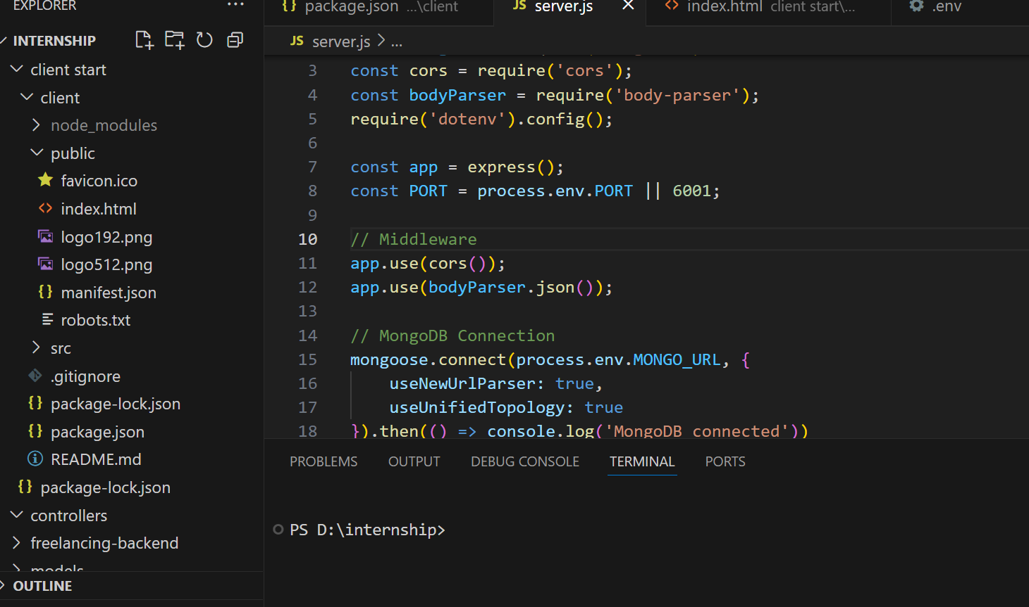

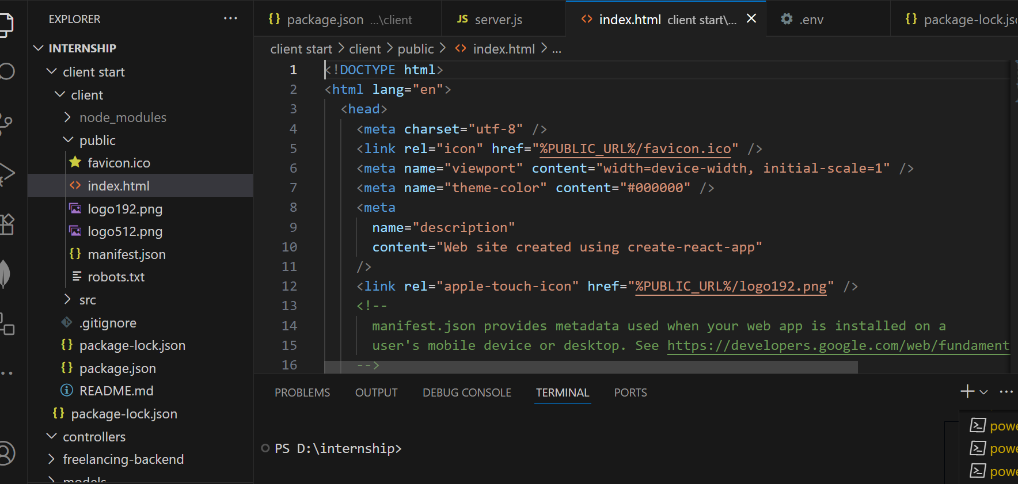

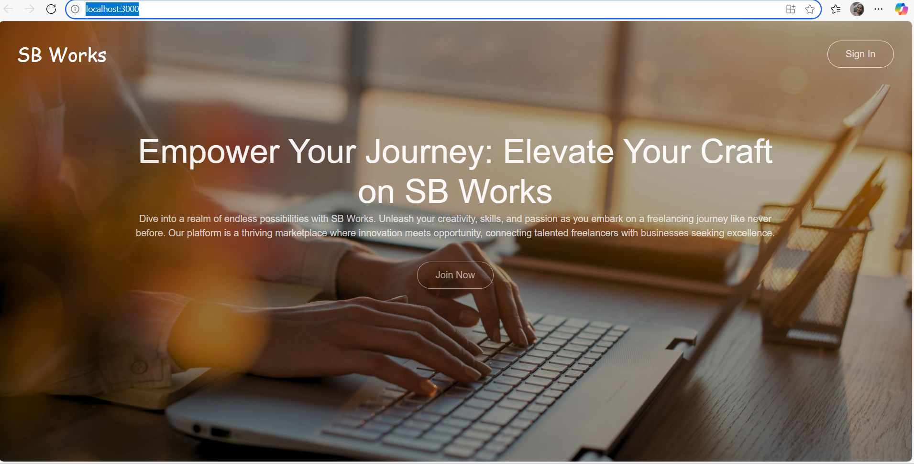

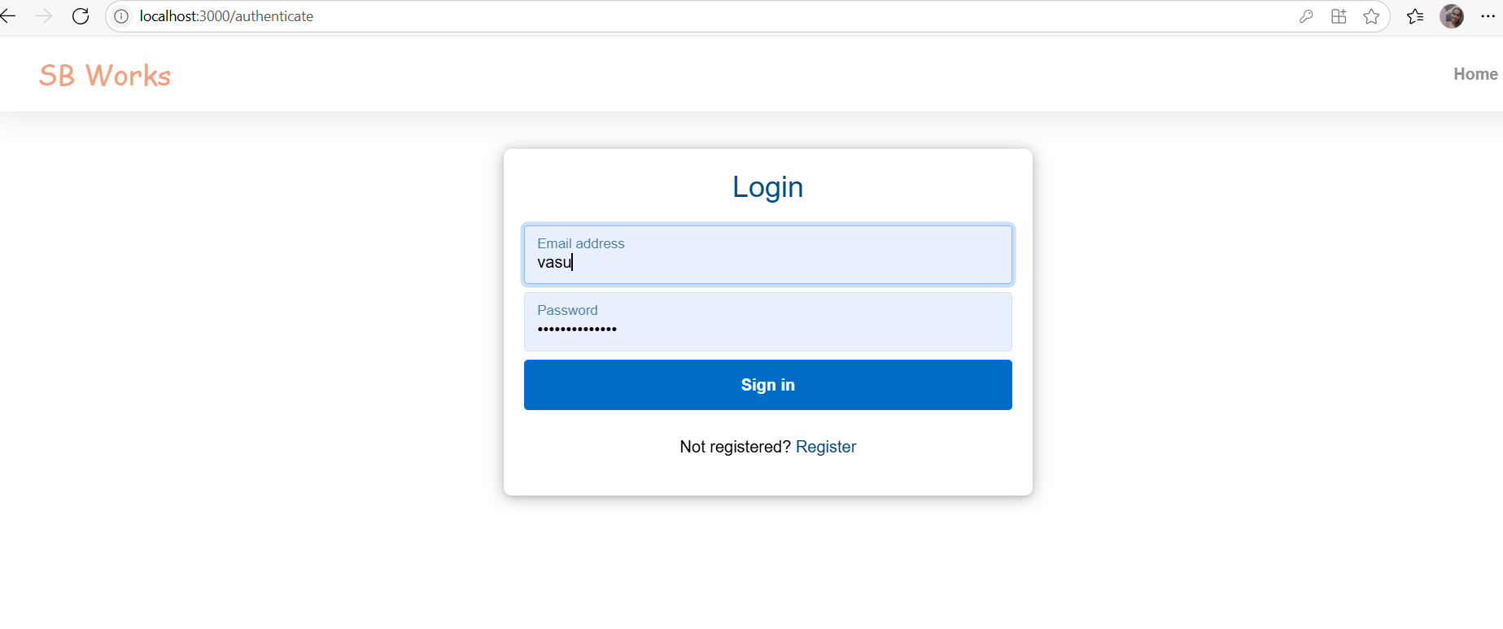

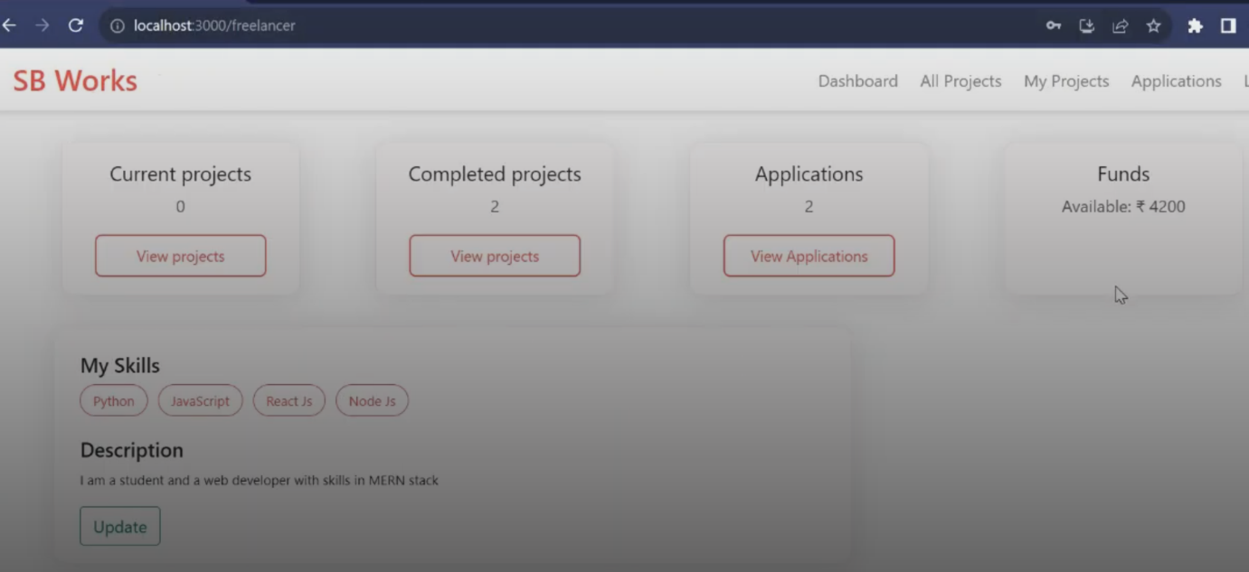

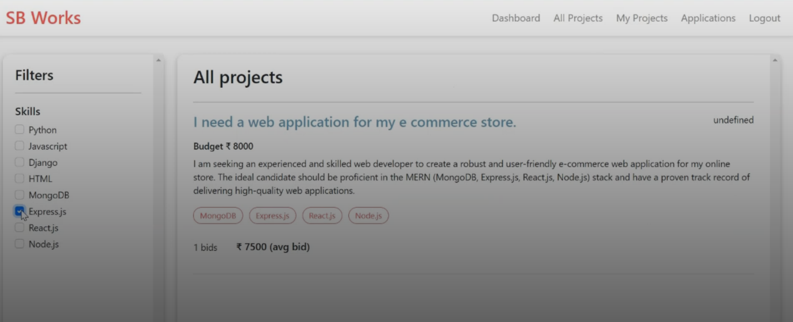



**Conclusion:-**

FreelanceFinder, through its meticulously analyzed and proposed system, offers a robust solution to the existing challenges within the gig economy. By prioritizing enhanced talent discovery, secure financial transactions, and streamlined collaboration, the platform is poised to empower freelancers and provide clients with reliable access to quality expertise. Our comprehensive testing strategy ensures a high-quality, stable, and user-centric application, ultimately unlocking new opportunities and fostering significant potential for both individuals and businesses in the evolving landscape of work.